### Title: Media Store with Database

**Course:** CMPSC 221

**Group#:** 8

**Members:** Jie Zheng, Dilnur Yulda

## Class Hierarchy:

GUI

Access

DataBase

Movie

MediaStore

AudioBook

Customer

Manager

Account

Album

Media

## 1. E-R Diagram:

## Jason's Mac:Users:Jason:Desktop:Screen Shot 2013-04-18 at 6.39.08 PM.png

## 2. Database initialize:

create table users

(

user_id varchar(30) not null,

name varchar(30),

credit double,

purchase_num smallint,

address varchar(30),

constraint pk_users primary key (user_id)

);

create table medias

(

media_id smallint not null,

available smallint,

type varchar(30),

name varchar(30),

author varchar(30),

time varchar(30),

genre varchar(30),

rank smallint,

price double,

sold_num smallint,

rate_num smallint,

rate double,

rate_total double,

year_released smallint,

constraint pk_medias primary key (media_id)

);

create table purchases

(

user_id varchar(30) references users(user_id),

media_id smallint references medias(media_id)

);

create table rates

(

media_id smallint references medias(media_id),

user_id varchar(30) references users(user_id)

);

INSERT INTO users (user_id, name, credit, address)

VALUES ('jiz51180', 'Jie Zheng', 200, 'Burrowes Street, State College');

INSERT INTO users (user_id, name, credit, address)

VALUES ('jiz51181', 'Jie Zheng', 200, 'Burrowes Street, State College');

INSERT INTO users (user_id, name, credit, address)

VALUES ('jiz51182', 'Jie Zheng', 200, 'Burrowes Street, State College');

INSERT INTO medias (media_id ,type, name, author, time, genre , rank , price ,year_released )

VALUES (0, 'movie', 'Skyfall0', 'Sam Mendes', '2:30:00', 'Action & Adverture', 1,14.99,2012);

INSERT INTO medias (media_id, type, name, author, time, genre , rank , price ,year_released )

VALUES (1,'movie', 'Skyfall1', 'Sam Mendes', '2:30:00', 'Action & Adverture', 1,14.99,2012);

INSERT INTO medias (media_id, type, name, author, time, genre , rank , price , year_released )

VALUES (2,'movie', 'Skyfall2', 'Sam Mendes', '2:30:00', 'Action & Adverture', 1,14.99,2012);

INSERT INTO medias (media_id, type, name, author, time, genre , rank , price , year_released )

VALUES (3, 'music', 'Two Lanes of Freedom0', 'Tim MCGraw', '43:24', 'Country', 1,13.99,0);

INSERT INTO medias (media_id ,type, name, author, time, genre , rank , price , year_released )

VALUES (4,'music', 'Two Lanes of Freedom1', 'Tim MCGraw', '43:24', 'Country', 1,13.99,0);

INSERT INTO medias (media_id ,type, name, author, time, genre , rank , price , year_released )

VALUES (5, 'music', 'Two Lanes of Freedom2', 'Tim MCGraw', '43:24', 'Country', 1,13.99,0);

INSERT INTO medias (media_id ,type, name, author, time, genre , rank , price , year_released )

VALUES (6, 'audioBook', 'American Sniper0', 'Chris Kyle', '10:22', 'Biography', 1,21.95,0);

INSERT INTO medias (media_id, type, name, author, time, genre , rank , price , year_released )

VALUES (7, 'audioBook', 'American Sniper1', 'Chris Kyle', '10:22', 'Biography', 1,21.95,0);

INSERT INTO medias (media_id ,type, name, author, time, genre , rank , price , year_released )

VALUES (8,'audioBook', 'American Sniper2', 'Chris Kyle', '10:22', 'Biography', 1,21.95,0);

update medias set available=1,sold_num=0,rate_num=0,rate=0,rate_total=0;

update users set purchase_num=0;

**3. Table Explanation:**

Users Table :

Data Member: user_id, name,credit ,purchase_num and address

Role: To store user account information

Medias Table:

Data Member: See the E-R Diagram (Too much to list in single line)

Role: To store media information (including Movie Music and AudioBook)

Purchases Table:

Data Member: user_id, media_id (multi to multi relation)

Role: To check if certain user had already purchased particular media to avoid multiply purchase. (ifPurchase() can be remove to allow multiply purchase, For this program multiply is not allowed )

Rates Table

Data Member: media_id, user_id

Role: To check if certain user had already rated particular media to avoid multiply rate. (multiply rate should be prohibited in any case, otherwise the average rate will be manipulate by single user)

**4. Task Distribution**

Transiting from Phase 2 to Phase 3, We modified almost all the function from phase 2 and using table instead of Arraylist<> to insert, modify and display the data. In order to better manage the function that need access to the database, we moved all the function that need to access the database to the TopLeveGUI class. We setup the database same way as what you show us in the class in EmbeddedDerbyDemo project. We mainly used only one Connection, Statement and ResultSet in the project unless we need to access additional ResultSet. In the case that we need to access different ResultSet, We created a tempStatametn and tempResultSet to avoid the conflict; otherwise there will be “ResultSet not open error”. In the end we debug the program together. There is a bug when trying to add a customer with 0 credit, we go to the code to solve it so that only customer with negative credit will not be allow to add.

## 5 Sample Runs:

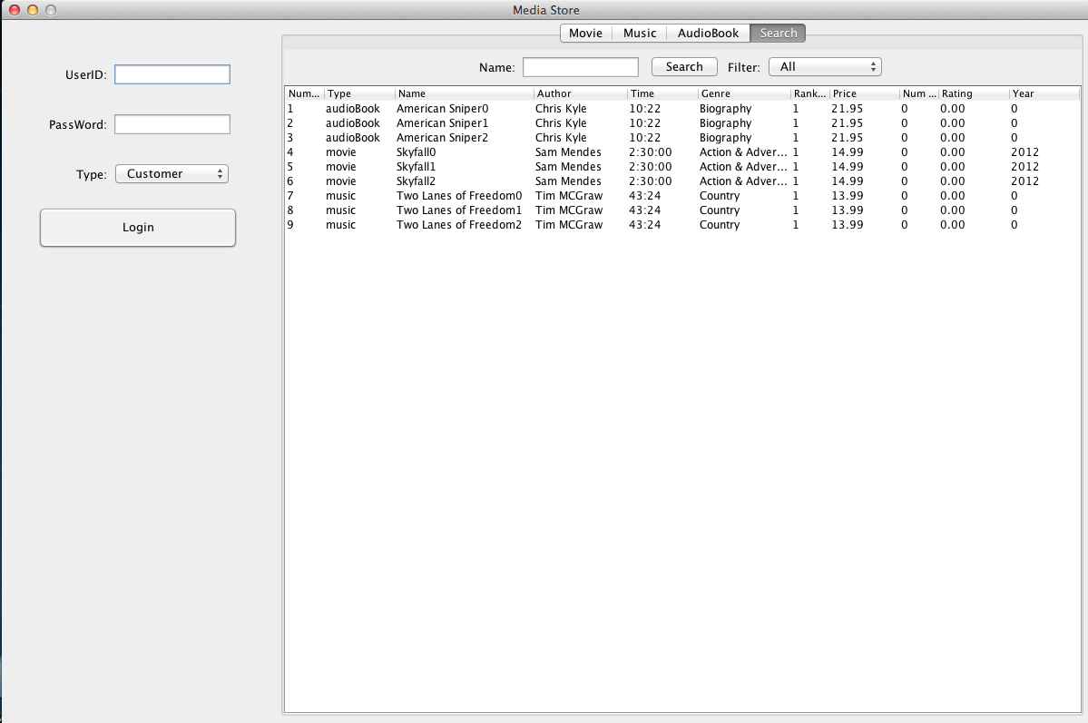

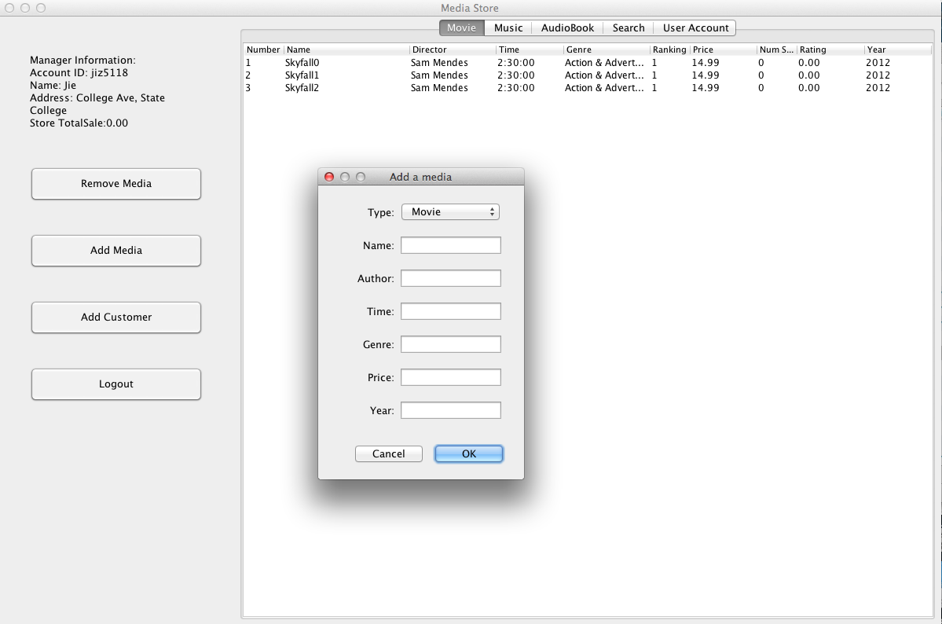

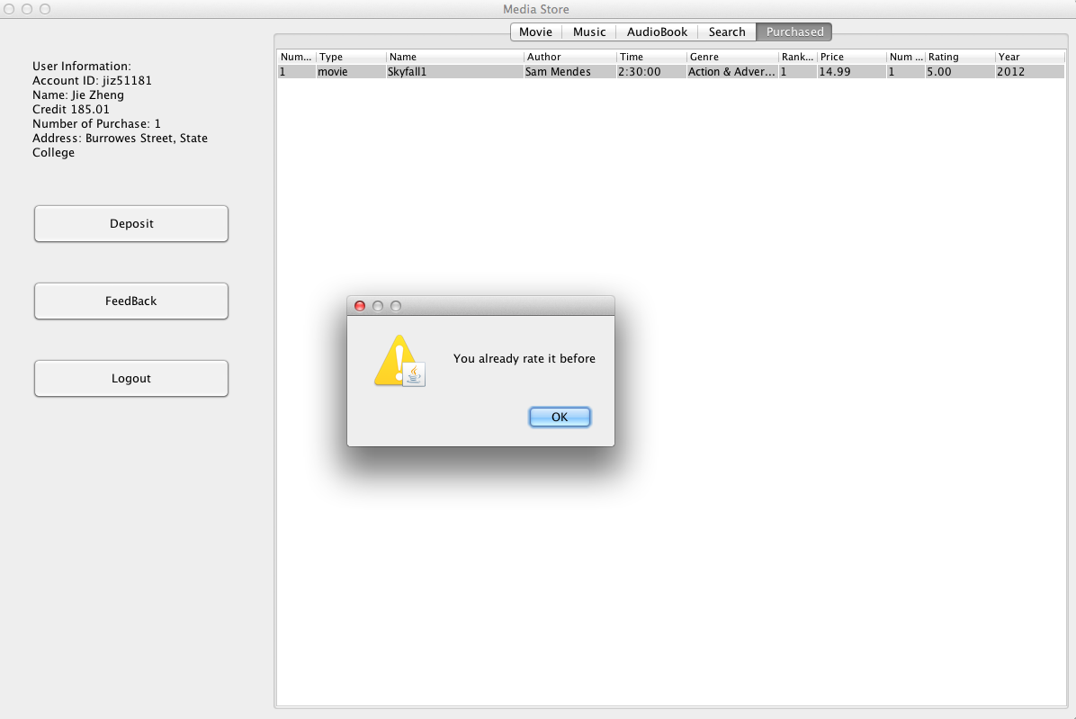

**Account:**

For manager

username jiz5118

password 123

Some customer

username jiz51180

username jiz51181

username jiz51182

no password require for customer.